**Module – 1**

**THEORY**

**OVERVIEW OF IT**

**INDUSTRY**

1. **What is Program?**

**Ans. Programming is process of writing instruction for a computer to follow in order to solve the problems. It’s collaboration between humans & computers.**

1. **Explain in your own words what a program is & how it functions?**

**Ans. A program is a set of instruction written in a specific language that tells computer exactly what to do step by step to perform a given task.**

1. **What is programming?**

**Ans. Programming is done to perform a particular task in language (Code) which computer can easily understand is known as programming.**

1. **What are the key steps involved in the programming process?**

**Ans. The key steps in programming language are design, coding, testing, debugging & maintenance.**

1. **Types of programming languages?**

**Ans. There are many types of programming language including procedural, functional, object – oriented, scripting, logic, frontend & compile languages.**

1. **What are the main differences in high level & low level programming languages?**

**Ans. The difference between high level & low level programming language is as follow.**

**High Level**

1. **High level programming language is easily read & understands by humans.**
2. **High level language is in English readable statement.**
3. **High level language is easy to learn & use.**
4. **For example Python, Java, COBO etc.**

**Low Level**

1. **Low level programming language is easily understood by computers.**
2. **Low level uses binary or assembly language, which is difficult for humans to understand.**
3. **Low level language requires detailed knowledge of computer architecture .**
4. **For example Machine language & Assembly language.**
5. **World Wide Web & How Internet Works?**

**Ans. The World Wide Web (WWW) is a collection of websites that are linked together by hyperlinks & access through the internet. The WWW works by using a client-server model, where a client requests documents from a server.**

1. **Describe the role of the client server in web communication**

**Ans. In a web communication, a client is the device or application that initiates a request for information or services from a server, which is the computer that processes the request & sends back the requested data, whatever is asked by the client for something & server provides it, where the client sends a request and the server sends a response back.**

1. **Explain the function of the TCP/IP model & its layers?**

**Ans. The functions are as follows:**

1. **Data Packaging: TCP/IP breaks data into smaller packets for transmission, allowing for more efficient routing & error recovering.**
2. **Addressing: IP (Internet Protocol) is responsible for assigning unique IP Addresses to device, enabling data to be directed to the correct destination.**
3. **Routing: IP determines the best path to send packets across network to reach their destination.**
4. **Reliable Delivery: TCP (Transmission Control Protocol) ensures reliable data transmission by managing packet sequencing, error detection & retransmission mechanism.**

**Layers of the TCP/IP**

1. **Application Layer: Handles user level applications like email, web browsing & file transfer, interacting with the network.**
2. **Transport Layer: Provides reliable data transfer between applications on different hosts, including flow control & error detection.**
3. **Network Layer: Responsible for routing packets across networks using IP addresses.**
4. **Link Layer: Managing the physical transmission of data on the local network.**
5. **Explain client server communication.**

**Ans. Client & Server communication refers to a network model where a client program request a service or information from a server program, which then processes the request & sends back a response. It Initiates a communication by sending request & server fulfills that request by sending back the necessary data to perform an action is known as client server communication.**

* **Client: The program or device that initiates a request for information or service from the server.**
* **Server: The program or device that provides requested service or information to the client.**

1. **How does broadband differ from fiber-optic internet?**

**Ans. Broadband is a general term for high-speed internet access, while fiber optic internet is a specific type of broadband that uses fiber optic cables to transmit data significantly faster speed with greater reliability, thanks to its use of light signals through glass fibers instead of electrical signals through copper wires.**

1. **What are the differences between HTTP & HTTPS protocol?**

**Ans. HTTP:**

1. **Hyper Text Transfer Protocol (HTTP) is a protocol using which hypertext is transferred over the web.**
2. **Due to its simplicity, HTTP has been the most widely used protocol for data transfer over the web but the data transferred through HTTP isn’t as secure as HTTPS.**
3. **In fact, hyper-text exchanged using HTTP goes as plain text i.e. anyone between the browser & server can read it relatively easily if one intercepts this exchange data.**

**HTTPS**

1. **Hypertext Transfer Protocol Secure (HTTPS) is an extended version of the Hypertext Transfer Protocol (HTTP). It is used for a secure communication.**
2. **In HTTPS, the communication protocol is encrypted using transport layer security.**
3. **HTTPS stands for Hypertext Transfer Protocol Secure.**
4. **Identify & explain three common application security vulnerabilities. Suggest possible solutions.**

**Ans. Three common application security vulnerabilities include: broken authentication (weak passwords), insecure data storage (sensitive information not encrypted), and improper input validation (SQL Injection).**

**Solution is implementing strong password policies with multi-factor authentication, encrypting sensitive data at rest & in transits & rigorously, validating user input to prevent malicious code injection.**

1. **What is the role of encryption in securing applications?**

**Ans. Encryption plays a critical role in securing applications by transforming sensitive data into an unreadable format, they cannot decipher it without the proper decryption key, effectively protecting confidential information like user logins, financial details, and medical records from unauthorized access or interception during transmission or storage within an application.**

1. **Identify & Classify 5 application you use daily as either system software or application software.**

**Ans. 5 application we use daily are: an internet browser (like Chrome & Firefox), a word processor (like Microsoft Word), an email client (like Gmail & Outlook), a communication app (like Zoom & Skype), and a file management system (part of operating system).**

1. **What is the difference between system software & application software?**

**Ans. System software provides a platform for other software to run, while application software performs specific task for the user, so both are necessary for your computer to work properly.**

**Differences are as follows:**

**System Software**

* **Memory Management**
* **Processor Management**
* **Security**
* **Error-detecting Aids**
* **Scheduling**

**Application Software**

* **Information & data management**
* **Management of documents**
* **Development of visuals & video**
* **Emails, text messaging, audio & video conferencing**
* **Management of accounting, finance & payroll**
* **Management of resources (ERP & CRM System)**

1. **Why are layers important in software architecture?**

**Ans. Layers are crucial in software architecture because they promote separation of concern by dividing an application into distinct fictional units, enabling easier development, maintenance, testing, and scalability by allowing each layer to be managed independently with each layer focused on a specific task, minimizing code complexity & improving overall system robustness.**

1. **Explain the importance of a development environment in software production.**

**Ans. A development environment is crucial in software production because it provides a dedicated space for developers to write, test & debug code without impacting live users, ultimately enhancing developer productivity, ensuring high quality software & minimizing errors by allowing experimentation in a controlled setting before deploying changes to the production environment.**

1. **What is the difference between source code and machine code?**

**Ans. Source code is the human readable set of instructions written by a programmer in a programming language, while machine code is the binary code that a computer directly understands and executes, essentially the translated version of source code that a computer can run; in simple terms, source code is what a programmer writes, and machine code is what the computer actually uses to run the program.**

1. **Why is version control important in software development?**

**Ans. Version control is important in software development because it helps teams work together more efficiently, reduces errors, and protects the source code.**

**Version control systems, also known as source control, track and manage changes to software code over time. Some examples of version control systems include Git and Subversion.**

1. **What are the benefits of using Github for students?**

**Ans. GitHub can help students learn and collaborate on software development projects.**

1. **How does GIT improve collaboration in a software development team?**

**Ans. Git enhances collaboration in a software development team by enabling developers to work simultaneously on different parts of a project using branches, allowing them to independently make changes and then merge them back into the main codebase, thus preventing conflicts and facilitating parallel development while maintaining version control; this feature, combined with pull requests, provides a structured way for team members to review and discuss each other's code changes, improving overall code quality and communication within the team.**

1. **What is the role of application software in businesses?**

**Ans. Application software plays a crucial role in businesses by automating tasks, managing data, facilitating communication, and supporting various business operations like accounting, sales, marketing, and human resources, ultimately improving efficiency, productivity, and decision-making capabilities within an organization; essentially allowing businesses to operate more effectively and serve customers better by streamlining processes and providing access to critical information.**

1. **What are the main stages of the software development process?**

**Ans. The main stages of the software development process are planning, design, coding, testing, deployment, and maintenance. This process is also known as the Software Development Life Cycle (SDLC).**

1. **Why is the requirement analysis phase critical in software development?**

**Ans. The requirement analysis phase is critical in software development because it lays the foundation for the entire development process by ensuring all stakeholders have a clear and shared understanding of what needs to be built, preventing potential issues like delays, miscommunication, and cost overruns by identifying and addressing user needs and system constraints early on in the project lifecycle.**

1. **What is the role of software analysis in the development process?**

**Ans. Software analysis plays a crucial role in the development process by thoroughly examining and documenting the needs of a system, ensuring that the final software product meets the required functionalities and user expectations by identifying and defining all necessary features, functionalities, and constraints before development begins, essentially acting as the foundation for the entire software design and implementation phases.**

1. **What are the key elements of system design?**

**Ans. System design is the art of creating a blueprint for a system that meets specified requirements, solves user problems, and handles future growth. A well-designed system is scalable, reliable, maintainable, and secure, making it an essential aspect of software engineering.**

1. **Why is software testing important?**

**Ans. Software testing is important because it helps ensure that software is high quality, secure, and performs as expected. It also helps to improve user experience and satisfaction.**

1. **What types of software maintenance are there?**

**Ans. Software Maintenance refers to the process of modifying and updating a software system after it has been delivered to the customer. This involves fixing bugs, adding new features, and adapting to new hardware or software environments. Effective maintenance is crucial for extending the software’s lifespan and aligning it with evolving user needs. It is an essential part of the software development life cycle (SDLC), involving planned and unplanned activities to keep the system reliable and up-to-date.**

1. **What are the key differences between web and desktop applications?**

**Ans. The primary difference between web and desktop applications is that web applications are accessed through a web browser and require an internet connection to run, while desktop applications are installed directly on a user's computer and can function offline, allowing for greater performance and access to local system resources; essentially, web apps are accessed from anywhere on any device with internet, while desktop apps are limited to the specific computer they are installed on.**

1. **What are the advantages of using web applications over desktop applications?**

**Ans. The main advantages of using a web application over a desktop application are its accessibility from any device with an internet connection, automatic updates, cross-platform compatibility, no installation required, easier maintenance, and generally lower development costs compared to dedicated desktop software; essentially, users can access web applications from any computer or mobile device without needing to install specific software on their system.**

1. **What role does UI/UX design play in application development?**

**Ans. UI/UX Design, referred to as “User Interface/User Experience design,” has become very important in the field of application design focusing on creating a visual interface and improving the experience of the user. The role of a UI/UX designer is to ensure that the application, or software is user-friendly and visually appealing for the user.**

1. **What are the differences between native and hybrid mobile apps?**

**Ans. Native apps are built for a specific platform, like iOS or Android, while hybrid apps are built to work across multiple platforms. Native apps tend to perform better than hybrid apps.**

1. **What is the significance of DFDs in system analysis?**

**Ans. A Data Flow Diagram (DFD) is significant in system analysis because it provides a visual representation of how data moves through a system, allowing analysts to easily understand the relationships between different processes, data stores, and external entities, which helps identify potential bottlenecks, inefficiencies, and areas for improvement, ultimately facilitating better system design and communication among stakeholders.**

1. **What are the pros and cons of desktop applications compared to web applications?**

**Ans. Desktop applications generally offer faster performance and offline capabilities compared to web applications, as they run directly on the user's computer, but they are limited by platform compatibility and require installation, while web applications are accessible from any device with an internet connection, making them more widely accessible.**

1. **How do flowcharts help in programming and system design?**

**Ans. Flowcharts aid in programming and system design by providing a visual representation of a process or algorithm, allowing developers to easily understand the logic, identify potential issues, and communicate complex ideas to others before writing code, essentially acting as a blueprint for the system by outlining the steps, decisions, and data flow involved in a program or system design.**

1. **Research and create a diagram of how data is transmitted from a client to a server over the internet.**

**Ans.**

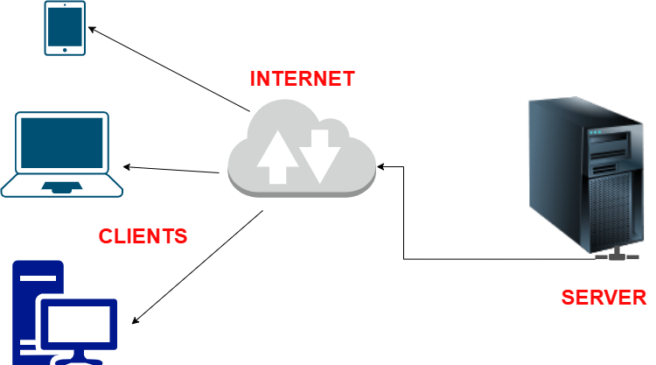

1. **Design a basic three-tier software architecture diagram for a web application**

**Ans.**

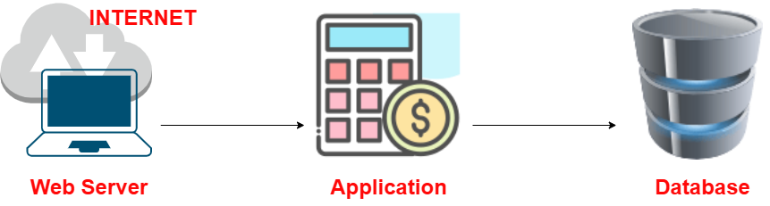

1. **Create a case study on the functionality of the presentation, business logic, and data access layers of a given software system.**

**Ans.**